Tascam joins Sennheiser’s “AMBEO for VR” partnership program

Wedemark/Tokyo, December 21, 2017 – Sennheiser today announced that the TEAC Corporation and its TASCAM brand of professional video and broadcast equipment is joining the “AMBEO for VR” partnership program. Created to ensure seamless production workflows and interoperability for VR, AR and other 3D content creators, this Sennheiser program includes collaborations with acclaimed manufacturers of field recorders, VR live cameras, live streaming software, mixing plug-ins and VR platforms.


A leading manufacturer of audio systems for video production and broadcast applications, TEAC has released new firmware for its TASCAM DR-701D six-track audio recorder. Version 2.0 of the firmware now includes the Sennheiser A-to-B converter for recording the A or B format from the Sennheiser AMBEO VR Mic.

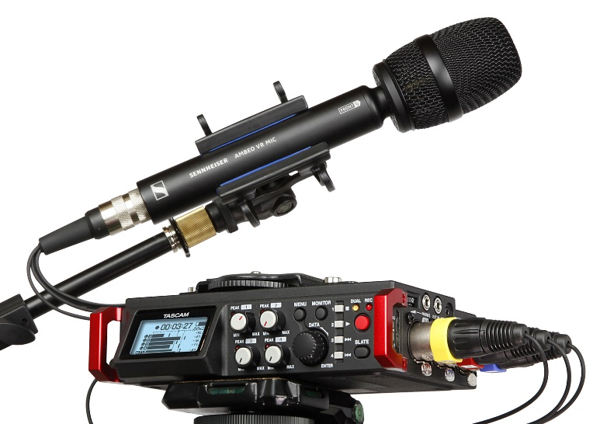 | Supporting the rapidly growing number of VR productions, TEAC and Sennheiser are proud to announce that the new firmware 2.0 for the TASCAM DR-701D recorder now includes the A-to-B converter for the AMBEO VR Mic.  

“Sennheiser warmly welcomes the TEAC Corporation to the AMBEO for VR partnership program,” said Véronique Larcher, AMBEO Immersive Audio Co-Director at Sennheiser. “We are proud to have their TASCAM DR-701D audio system on board, as it is a product held in high esteem by content creators across the globe. Thanks to the new firmware, the TASCAM recorder now fully supports the AMBEO VR Mic for recordings in A or B format Ambisonics.”

“For years, TASCAM has supported audio professionals in the areas of video production and broadcast, and we are proud to partner with Sennheiser AMBEO to support the rapidly growing world of VR,” said Yuji Hanabusa, President and CEO of TEAC CORPORATION. “The addition of Ambisonics support to our industry-leading DR-701D will enable yet another dimension of creativity for DR-701D owners and will help to shape the future of digital entertainment, education and information sharing.”

To download the version 2.0 firmware for the TASCAM DR-701D please visit: https://tascam.jp/int/product/dr-701d/download/
https://tascam.jp/int/

About TASCAM
TASCAM is the professional audio division of TEAC Corporation and produces the most comprehensive line of audio recorders, mixers and related equipment in the professional audio industry. TASCAM has offices in the U.S., Germany, Japan, Mexico and Latin America.

About Sennheiser
Sennheiser is shaping the future of audio – a vision built on more than 70 years of innovation culture, which is deeply rooted within the family-owned company. Founded in 1945, Sennheiser is one of the world’s leading manufacturers of headphones, microphones and wireless transmission systems. With 20 sales subsidiaries and long-established trading partners, the company is active in more than 50 countries and operates its own production facilities in Germany, Ireland and the USA. Sennheiser has around 2,800 employees around the world that share a passion for audio excellence. Since 2013, Sennheiser has been managed by Daniel Sennheiser and Dr. Andreas Sennheiser, the third generation of the family to run the company. In 2016, the Sennheiser Group had sales totaling €658.4 million. www.sennheiser.com

Local Contact Global Contact

Jeff Touzeau Stephanie Schmidt
jeff@hummingbirdmedia.com stephanie.schmidt@sennheiser.com
+1 (914) 602-2913 +49 (5130) 600 – 1275

